1. Group 1.

* Please mentioned the name of the Test that you use for final project AND provide the reason why you use that Test!
* Please create a flowchart/illustration to determine which Test that need to be used! (please have a look on the next slide for the example)

1. Test used:
2. Cross Correlation Test:

A cross correlation test, in general, is a test that determines how well one time series data predicts another. Hence, our final project uses this test in order to evaluate the correlation between average temperature and average CO2 emission time series data.

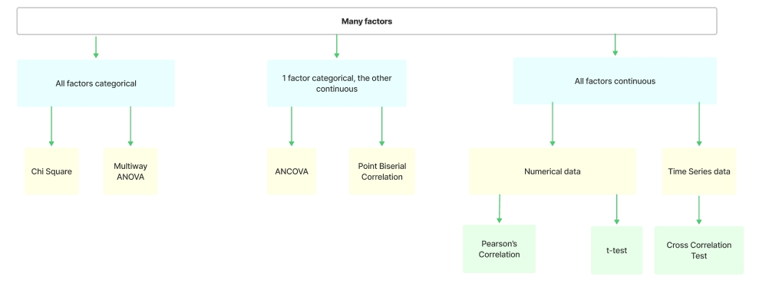

1. Individual

Please provide the example of mixed method research! (what kind of case)

For example, we wish to investigate the safety of a specific road. If the daily average number of traffic accidents and the areas where they occur are our primary metrics, we can adopt a strictly quantitative strategy. We can interview drivers to get their opinions about driving on particular stretches of road for qualitative research.